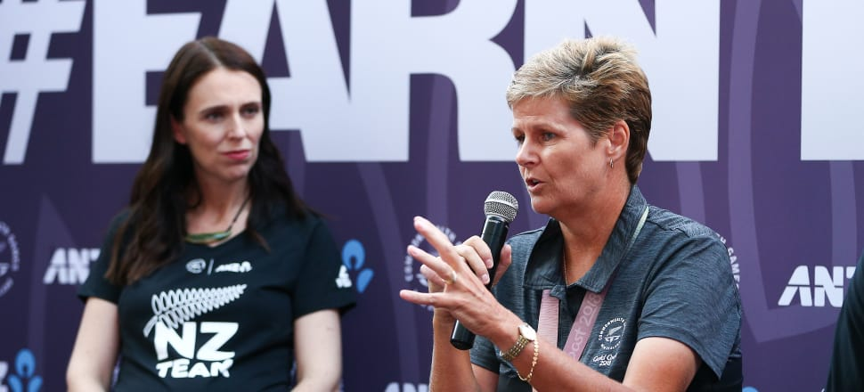

After four Commonwealth Games and three gold medals, Jo Edwards feels her sport finally has the respect it deserves from her fellow athletes. Suzanne McFadden reports.
A fuzzy green ball sits in the heart of Jo Edwards’ bowling bag. It travels the world with her, as both a talisman and a tool to her success on the green.
At every game Edwards rolls up to, she goes through the exact same preparation ritual. She arrives at the bowling green, opens her bag and gets her bowls ready, then pulls out the green tennis ball.
She then takes a walk around the carpark or on the street outside, putting the ball through its paces. Bouncing and catching it; throwing it against a wall. It's the same routine she's followed for the last 10 years.
It’s a valuable exercise in hand-eye coordination, she says. But there’s more to it than that.
“It just gets you going,” says Edwards, the four-time world champion and three-time Commonwealth gold medallist. “I may look a bit of a dick doing it, but hey.
"When I used to play soccer [also for New Zealand], we’d always do a warm-up. So in my little mind, it’s just something that really works for me.”
Edwards has honed her habits with John Quinn, the mental skills trainer for the BlackJacks, among other top Kiwi sports teams. “He’s one remarkable fella,” she says. “We talk about pre-shot routines, so I’m doing the same thing before every bowl, and we also talk about the importance of your pre-game routine.
“The tennis ball does its job. But it also doubles as a jack if you don’t have one, just quietly.”
That ball has been getting a hammering these past few weeks. First at the Broadbeach Bowls Club, where Edwards won her second-straight Commonwealth Games gold in the women’s singles. Then this week at the Naenae Bowling Club, where she’s played for the Blackjacks against a host of Australian teams in the Bowls Premier League – the Twenty20 form of lawn bowls.
It’s important to Edwards that others see the mental workout she goes through before, and during, a game. Apart from her medal, it was the most rewarding victory she took from the Gold Coast Games.
Bowls has always drawn derision from those who see it as a sport requiring little athletic prowess or mental tenacity. But the first time in 16 years, and at her fourth Commonwealth Games, Edwards finally felt like a true athlete in the New Zealand team.
“These Games were the most interactive that other sports have been with bowls. Other athletes were talking to us as sportspeople. In years gone by, you were just a bowler. But it’s really turned a corner,” she says
“We strive to show people that bowls is a bloody hard and really skilful sport."
Among those she enlightened were the women’s Black Sticks, who later won hockey gold. They watched Edward’s dramatic final, as she battled from behind to beat Welsh bowler Laura Daniels by four shots. “They said to me afterwards: ‘Oh my god, you really kept your cool. You were under pressure, but you just didn’t show it’. They were just amazed,” Edwards says.
“And I felt like … finally, you are seeing us as a sport. It may not be as physical as hockey, but we still put a lot into it.
“We strive to show people that bowls is a bloody hard and really skilful sport. So that was the really cool thing that came out of the Games.”
Edwards, now 48, knows how taxing it is at the elite tier of other sporting codes.
She was just 12 when she first played for the Nelson women’s cricket side. It was in that team she became friends with Val Smith, and they’d go on to represent their province in a string of sports.
Edwards and Smith made the Football Ferns soccer team for five years running. Then both women decided to give bowls a go, and together they became the best in the world – winning the women’s pairs at the 2008 world championship. They teamed up again on the Gold Coast, but didn’t make it past pool play in the pairs.
“Bowls is one of the hardest sports I’ve played,” says Edwards, who played on almost every day of the Commonwealth Games schedule.
“Rob Waddell [the New Zealand chef de mission] said to me: ‘You bowlers have such long days, day after day after day’. And I said ‘Yeah, but if you told us to play for another two weeks, we would’. It’s what we love doing.”
As long as every day doesn’t come with the same theatrics as her singles final. At one point she trailed 15-10, when Daniels couldn’t play a bowl wrong. “It’s great to be part of those good quality games, although you’d wish to win your final 21-0 every day of the week. It’s much better for your stress levels. But I suppose if you could write it in a fairy tale, that’s how you’d do it. A big bowl at the end to win it.”
While Edwards has become a creature of habit, there was one significant change to her game on the Gold Coast. For the first time in a very long time, her husband Dave Edwards – known universally in bowls as Scruff – was sitting in the crowd to watch her play.
For nine years, Scruff was the New Zealand team coach. “We used to divorce ourselves every time we went to a tournament with the New Zealand team. As we’d walk in, I’d give him a kiss and say ‘See you next Friday’ and we’d stay in different rooms,” Edwards says. “It was hard sometimes, but I’m really proud that we did it like that.

“If there’s one thing I can be proud of in my whole career, it’s that I turn up to events prepared. I have this one fear – that one day I won’t be prepared, I won’t succeed, and I’ll hate myself."
“So it was cool that he could just be a spectator, with no pressure, and no fear of the results affecting funding. He was watching me as his wife. When I looked up at him, he’d just give me a smile.”
This weekend, Mr and Mrs Edwards will return to Nelson, their home town, to reunite with family and friends. Last year the couple moved to Queensland, where Dave is now the bowls development officer and coach at Club Pine Rivers, north of Brisbane.
“We’re renting a nice apartment at the back of a park, where you look out the window and wonder which shorts you’re going to wear today,” Jo says. “We see it as a wee reward for all the hard work Scruff’s done.”
There were obvious benefits for Jo, too. She could become accustomed to the speed of Queensland greens – which are slower than New Zealand’s – and play against the state’s top men bowlers week in, week out.
She’s unsure when they will come back to New Zealand. And for that matter, whether she will continue to play bowls for her country.
“It’s a funny situation. All your life you put plans in place and timeframes, and we don’t have any plans. It’s a bit scary, but it’s refreshing as well,” Edwards says.
“I work on two-year cycles. If you’re not committed to the next world bowls championship in 2020, you’ve got to get out now and give someone else a chance to have the preparation. Four years is too long to consider. So to say the Commonwealth Games Birmingham in 2022 is a definite, it’s just not me.
“People often make decisions on emotions, so I always give myself a good three months to have a look and think, ‘Yeah I do want to go again’. It’s time to clear my head and work out the next challenge.”
Edwards took an 18-month complete break from the game in 2009, tired from the rigours of three decades of competitive sport. She knows had she not taken that breather, she wouldn’t have been standing on the top step of the dais in Broadbeach three weeks ago.
But it is certain she will represent New Zealand again – she’s qualified to play at the world singles champion of champions tournament in Sydney in October. And she won’t be going into it half-heartedly.
“If there’s one thing I can be proud of in my whole career, it’s that I turn up to events prepared. I have this one fear – that one day I won’t be prepared, I won’t succeed, and I’ll hate myself,” she says.
“Right from my debut in 2001 that has stayed with me. I can honestly hand on heart say with every big event I do prepare well. And that’s something I know I can be proud of when I finish my international career.”

